**MIND STORM SOFTWARE PVT LTD**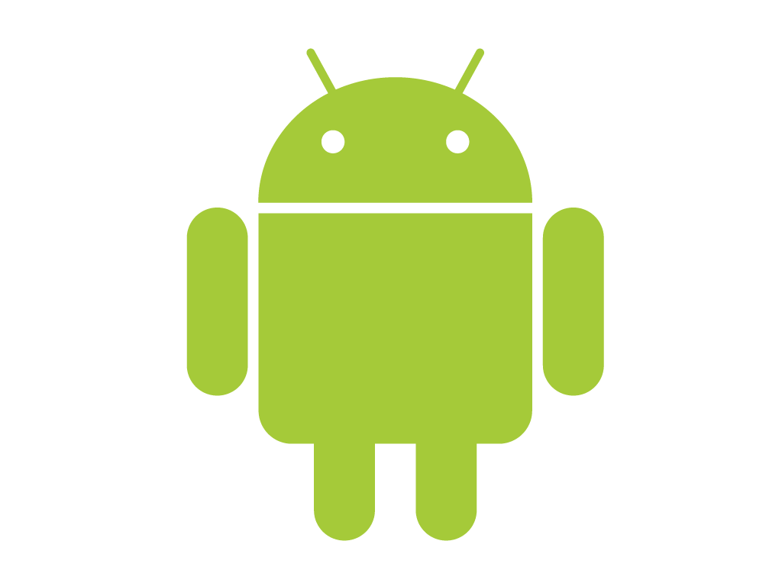

**Hands-On Exercise – ex01.doc**

**Objective**Write our first Android application. This exercise is meant to write your first application and in the process get familiar with the Eclipse based tools for writing Android applications. We will also enhance the application with a small feature.

**Assumptions**

* Development Environment for Android (Java SDK, Eclipse, Android SDK) has been setup successfully.
* You are familiar with using Eclipse.
* Android SDK 2.3.3 is available and Android Virtual Devices are already created.
* Start the Android Virtual Device to save time.
  + Click on **Window 🡪 Android SDK and AVD Manager**.
  + Select an **Android 2.3.3** compatible AVD and click on **Start**

Select **Scale display to real size** and provide a **Screen Size (in)** as **5 inches** or any other appropriate size for your development machine.

**If you have not setup the environment, please refer to Android Dev Environment Setup.docx for the instructions.**

**Do not proceed without completing that.**

**Step by Step Instructions**

Let us do a few checks first to ensure that your environment is setup and running.

1. Launch Eclipse
2. Check if Java SDK is setup in Eclipse. Click on **Window 🡪 Preferences.** Then go to **Java 🡪 Installed JREs** as shown below. Ensure that a Java environment is selected.

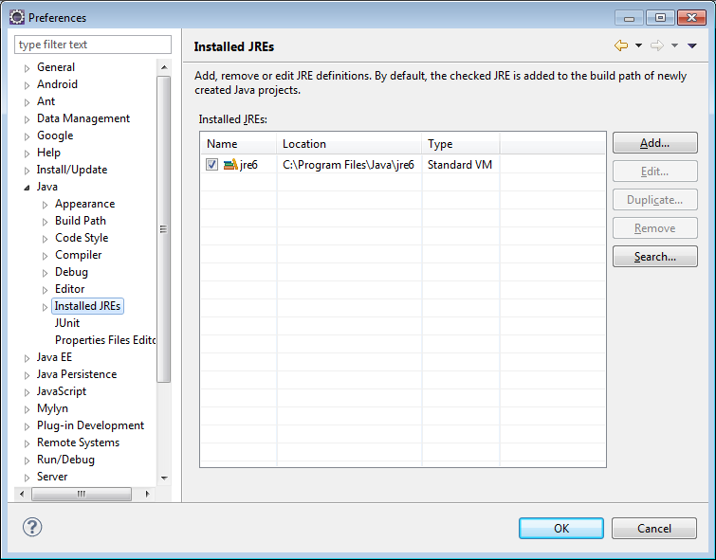

1. Check if Android SDK is setup in Eclipse. Click on **Window 🡪 Preferences.** Go to Android as shown below and ensure that the Android SDK versions are loaded as shown below. You may not have all the Android SDK Versions but at least you should have Android 2.3.x. If you have Android 4.x only, feel free to proceed with that too. Everything should work fine.

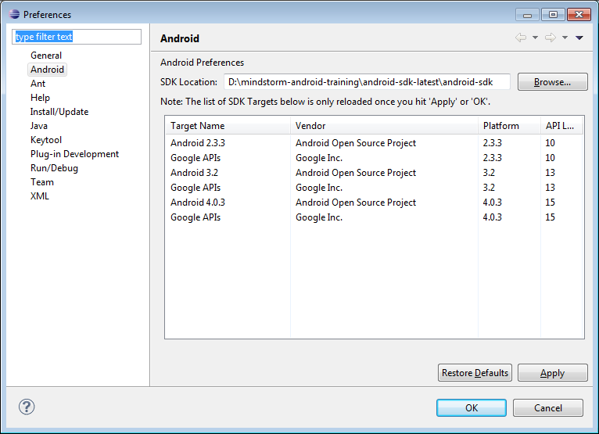

**Create the AVD** if not created and Start it.

1. Click on **Window 🡪 AVD Manager**. This will bring up the window as shown below:

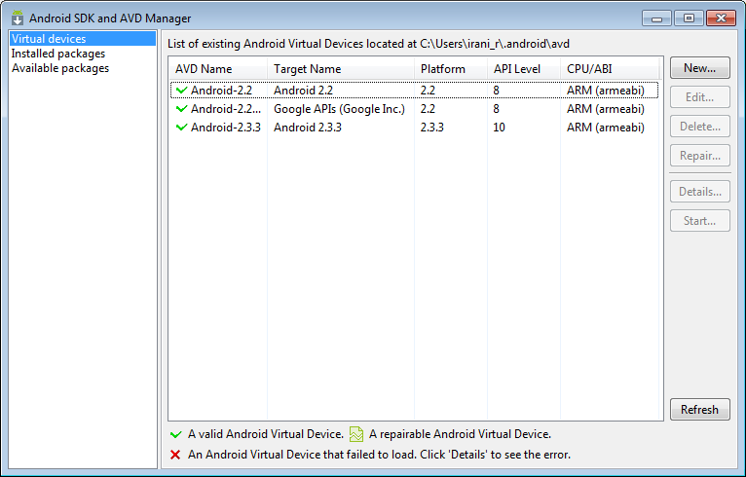

1. If there are no AVDs, create one for the appropriate Android version that you want to target. This can be done by clicking on **New** and filling up the details as shown below:

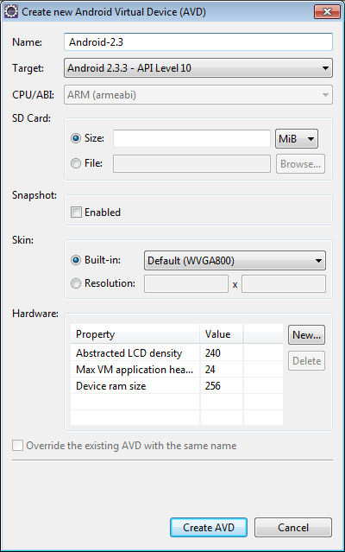

Click on **Create AVD** to create the Android Virtual Device. It will now appear in the list of AVDs in the Android SDK and AVD Manager.

Select one of them and click on **Start**. Adjust the Screen size if needed:

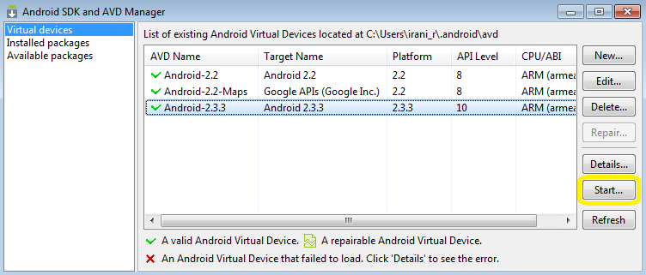

Once the AVD is started, unlock the screen and you should see a screen that looks like this:

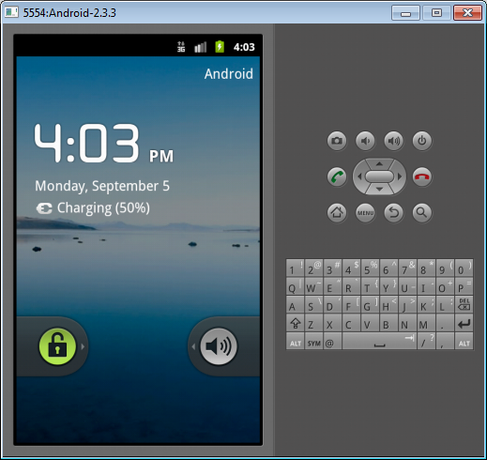

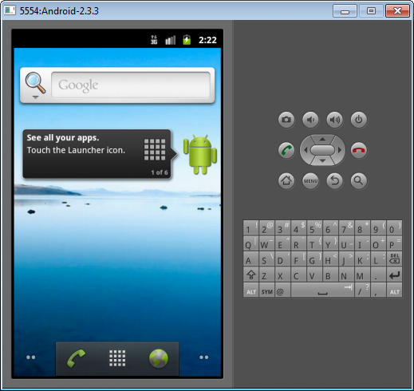

**Create the Project:**

1. In Eclipse, click on **File 🡪 New 🡪 Android Project**.
2. This will bring up the New Project dialog as shown below:

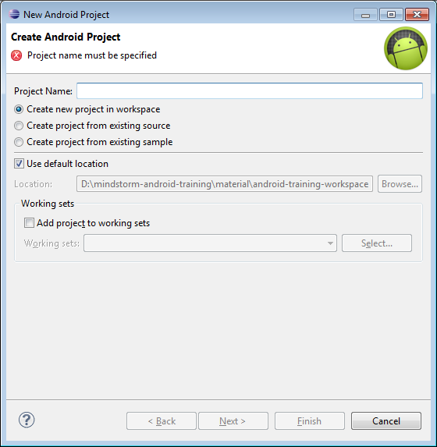

Give a Project Name. Please type in **AndroidHelloWorld** And click on the **Next**  button.

1. This will bring up the next step as shown below:

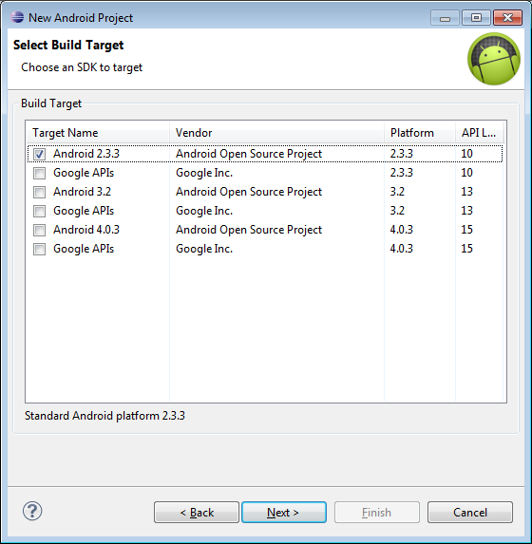

We need to select a **Build Target**. Select the version for which you have started the AVD (Not necessary though and you can pick anyone). Go with **Android 2.3.3** for now.

Click on the **Next** button. This will bring up a screen where you need to provide the following:

* 1. Provide an Application name. Take the default name **AndroidHelloWorld** again. This will be the application name for your Android application and will be visible on the phone when you install.
  2. Provide a **Package Name** i.e. **com.mindstormsoftware.firstapp**
  3. You must provide an **Activity Name**. This is the main screen that will come up as part of the application which the user will interact it. Consider it as the main user interface screen for now. Go with the default name provided for you i.e. **AndroidHelloWorldActivity**.
  4. The filled up dialog is shown below:

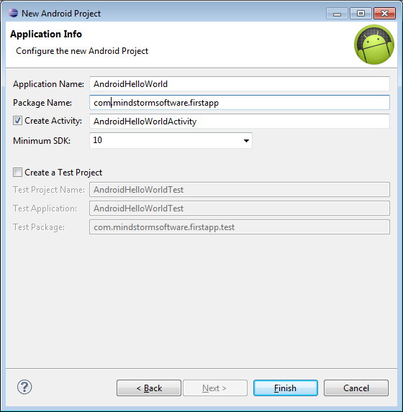

* 1. Click on **Finish**.

This will generate your Project. Look at the Project in the Project Explorer as shown below:

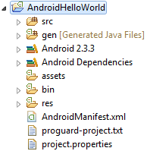

**Run the Application**

1. **Right click** the Project in the Project Explorer.
2. Select **Run As 🡪 Android Application**
3. Assuming that the Android Virtual Device for Android 2.3.3 is running, the console will display the messages as shown below where it will install the App on the Emulator and launch the Activity.

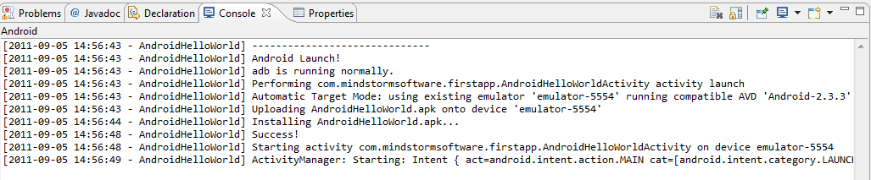

1. Switch to the **Emulator** and you should see your Application running now:

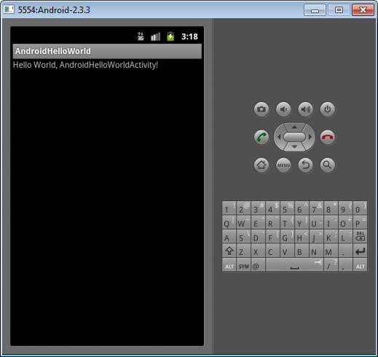

**Code Walkthrough**

Take a look at the code that is generated. The next few screens show the different parts of the project that you should focus on.

**Project Directory**

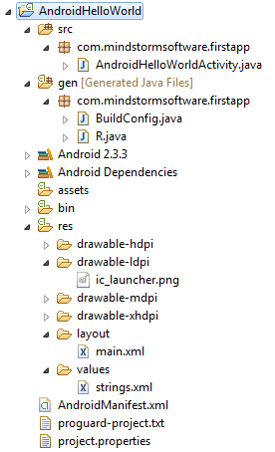

**Main Activity – AndroidHelloWorldActivity.java**

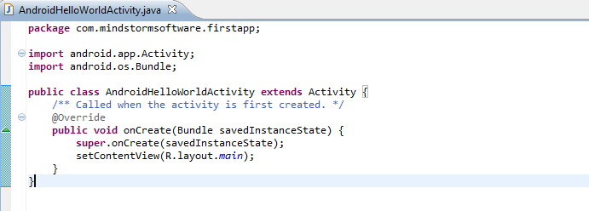

**Main Layout File – res/layout/main.xml**

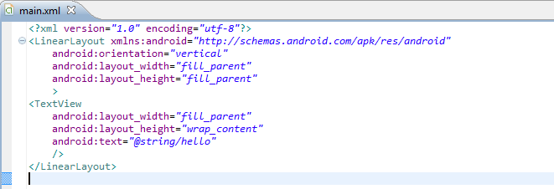

**All resource Strings – res/values/strings.xml**

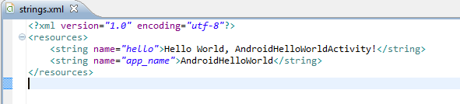

**The R file.**

All the resources are weaved into this file and can be referenced from code.

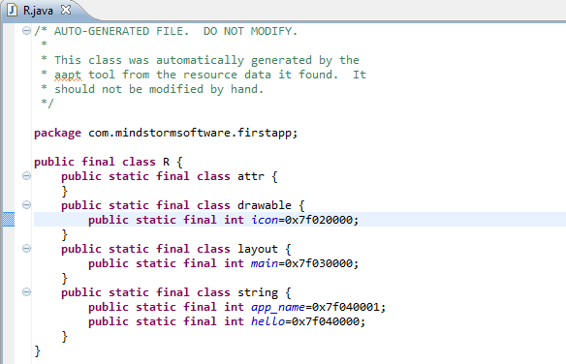

**Android Manifest file – AndroidManifest.xml**

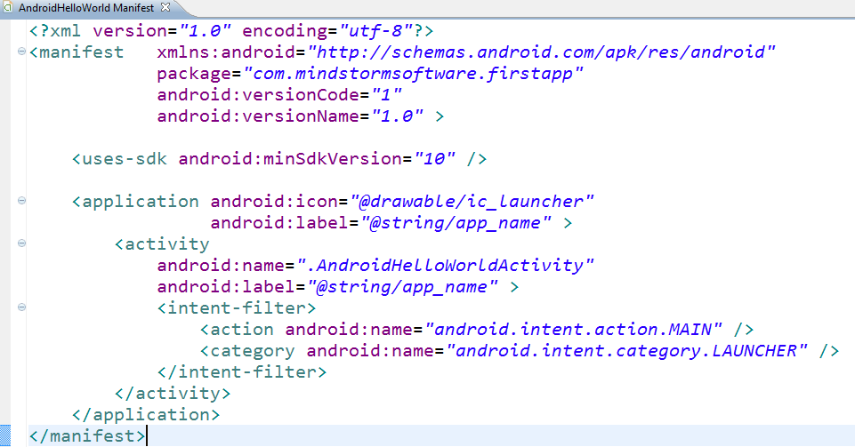

**Try out the following**

1. We shall add a Button to the main activity

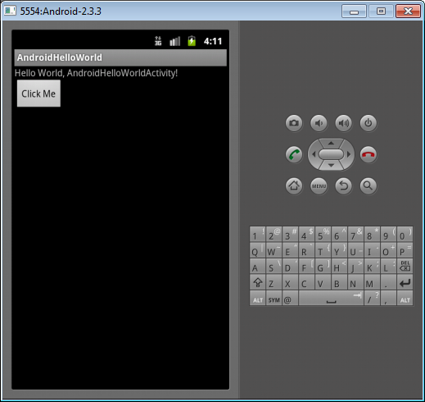

1. On the click of this button, we shall display a message to the user

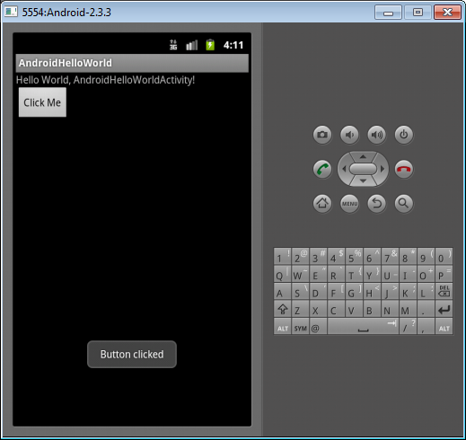

**Steps**

1. Go to **res/layout/main.xml** and add the highlighted piece of text:

<?xml version=*"1.0"* encoding=*"utf-8"*?>

<LinearLayout xmlns:android=*"http://schemas.android.com/apk/res/android"*

android:orientation=*"vertical"*

android:layout_width=*"fill_parent"*

android:layout_height=*"fill_parent"*

>

<TextView

android:layout_width=*"fill_parent"*

android:layout_height=*"wrap_content"*

android:text=*"@string/hello"*

/>

<Button android:text=*"Click Me"* android:id=*"@+id/btnClickMe"* android:layout_width=*"wrap_content"* android:layout_height=*"wrap_content"*></Button>

</LinearLayout>

1. Go to **AndroidHelloWorldActivity.java** and enter the following piece of code as shown below:

**package** com.mindstormsoftware.firstapp;

**import** android.app.Activity;

**import** android.os.Bundle;

**import** android.view.View;

**import** android.view.View.OnClickListener;

**import** android.widget.Button;

**import** android.widget.Toast;

**public** **class** AndroidHelloWorldActivity **extends** Activity {

/** Called when the activity is first created. */

@Override

**public** **void** onCreate(Bundle savedInstanceState) {

**super**.onCreate(savedInstanceState);

setContentView(R.layout.*main*);

//Normal Button

Button btn1 = (Button)findViewById(R.id.*btnClickMe*);

btn1.setOnClickListener(**new** OnClickListener() {

@Override

**public** **void** onClick(View v) {

showToast("Button clicked");

}

});

}

**private** **void** showToast(String msg) {

Toast.*makeText*(**this**, msg, Toast.*LENGTH_SHORT*).show();

}

}

1. Save all your files.
2. Run the Project again. **Right-click Project** and select **Run As 🡪 Android** Application.
3. This should display the screen as shown below:



1. Clicking on the button will result in the message as given below:

